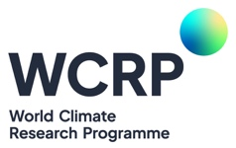
My Climate Risk Lighthouse Activity
Indication of Interest in establishing a My Climate Risk Hub

Thank you for your interest in establishing a My Climate Risk Regional Hub. You will find information relating to what a hub is and activities that the hubs typically undertake on our webpage: https://www.wcrp-climate.org/mcr-hubs. You can also find a list of recent activities, including a number of recorded webinars, on our webpage: https://www.wcrp-climate.org/mcr-events-opportunities. These will give you some idea of the goals of My Climate Risk.
If your organization is interested in becoming a hub, please complete the following indication of interest form and email to my-climate-risk@wcrp-climate.org.
- Name of organization/institute/university:
- City:
- Country:
- Name(s) of contact:
- Email address(es) of contact(s):
- Webpage (if you have one):
- Recent activities that align with My Climate Risk goals (please list relevant activities in the last 12 months):
- Future planned activities that align with My Climate Risk goals (please list relevant activities that you have planned):

- What current national, regional and international connections is your work aligned with?

- How would being a My Climate Risk hub help your future work?

